Wolds Weighton Update for September 2019
1. Crime and ASB
TFMV – Theft from motor vehicle
TOMV – Theft of motor vehicle
ASB – Anti-social behaviour
East Yorkshire-Wolds Weighton Ward |  |  |  | Last 12 months
 | This year compared to last year |  |  | 2019 | 2019 | 2019 | 2019 | 2019 | 2019 | 2019 | 2019 | 2018 | 2018 | 2018 | 2018
 | Sep 17 to Aug 18 | Sep 18 to Aug 19 | % Change year on year | Aug | Jul | Jun | May | Apr | Mar | Feb | Jan | Dec | Nov | Oct | Sep
All offences | 615 | 717 | +16.6% | 66 | 48 | 58 | 67 | 63 | 68 | 64 | 65 | 53 | 40 | 75 | 50
Burglary | 61 | 71 | +16.4% | 3 | 1 | 6 | 7 | 2 | 3 | 8 | 4 | 8 | 6 | 15 | 8
Criminal damage | 96 | 78 | -18.8% | 8 | 5 | 2 | 12 | 6 | 8 | 8 | 15 | 1 | 4 | 5 | 4
Drug offences | 4 | 12 | +200.0% | 1 | 0 | 1 | 0 | 1 | 0 | 2 | 2 | 1 | 0 | 2 | 2
Shop theft | 12 | 3 | -75.0% | 1 | 1 | 0 | 0 | 0 | 0 | 0 | 0 | 1 | 0 | 0 | 0
Sexual offences | 31 | 29 | -6.5% | 1 | 1 | 3 | 1 | 4 | 2 | 3 | 0 | 4 | 5 | 5 | 0
TFMV | 18 | 11 | -38.9% | 1 | 0 | 0 | 1 | 3 | 1 | 0 | 1 | 2 | 0 | 0 | 2
TOMV | 5 | 7 | +40.0% | 0 | 0 | 1 | 0 | 0 | 1 | 1 | 0 | 1 | 0 | 0 | 3
Thefts excluding vehicle and shop theft | 54 | 81 | +50.0% | 7 | 12 | 10 | 5 | 6 | 6 | 5 | 9 | 4 | 3 | 10 | 4
Violence against the person | 275 | 332 | +20.7% | 35 | 19 | 29 | 34 | 30 | 38 | 32 | 23 | 24 | 17 | 29 | 22
ASB | 134 | 76 | -43.3% | 9 | 6 | 10 | 8 | 4 | 5 | 5 | 8 | 5 | 9 | 3 | 4

In Market Weighton it is also worth noting that although some offence categories show that there has been a large percentage increase in crime compared to last year, this is primarily due to the number of offences committed last year being so low. For example, Drug Offences increased by 200% compared to the previous 12 months but in reality this was an increase of only 8 offences. 12 reports of Drug related offences for the entire Wolds Weighton ward in a year is very low in comparison to other areas in the UK. It is also worth mentioning that although 29 Sexual Offences were reported over the last 12 months, not all of these will include a physical assault and some may be victims reporting historical offences. Decreases of Shop Theft by 75% and ASB by 43% represent some of the notable positive outcomes of the year.

2. Crime issues of particular note
The following list shows some of the crimes that have occurred in the previous month in your area.
- A secure van parked on a driveway of a property in Sancton was broken into and tools stolen.
- There was an attempted burglary at a property in Market Weighton.
- A secure garage in Fridaythorpe was broken into and various items including tools were stolen.
- Front windows of a secure property in Wetwang were damaged but no entry was gained.
- A vehicle in Mkt Weighton was broken into and searched and a second vehicle was damaged.

3. Community Priorities
The Neighbourhood Policing Team meet regularly with partners to ensure we have a multi-agency approach to local issues, individuals and problem solving. These meetings are regularly attended by partners including Humberside Fire and Rescue Service, Youth and Family Support, Housing Officers, Environmental Health and the East Riding Anti-Social Behaviour Team. We share information and resources to deal with local neighbourhood issues, in particular, those identified as causing the most harm in the community.

- Market Weighton Town Centre area (Evenings):
We are to continue our high visibility patrols of the Market Weighton Town Centre area to deter potential anti-social behaviour (ASB). These patrols include regular checks on the High Street and peripheral areas of Londesborough Road Car Park, Scotts Croft Memorial Park, the town council building area and the area surrounding the Giant Bradley statue (periodic reports of youths causing annoyance). Criminal offenders will be challenged robustly, arrested or reported for summons. Penalty Notices for Disorder or warning letters may be used in appropriate cases however, those who offend should expect to be arrested and dealt with if their anti-social behaviour amounts to criminal offending.

- Youths Causing Annoyance (Evenings):
Officers will continue patrols in the areas of Aspen Close, the park, the monkey run & football field due to regular reports of low level anti-social behaviour. Anyone caught engaging in such activities will be dealt with jointly with the East Riding of Yorkshire Council.

- Vehicle related nuisance
To reduce anti-social behaviour (ASB) and its impact on the communities within the Wolds Weighton area as well as taking positive action against offenders who cause ASB with their vehicles. Hotspot areas will be checked regularly and any drivers using their cars to cause alarm or distress will be considered for warnings and possible seizure of their vehicles under Section 59 of the Police Reform Act.

4. Crime Prevention Advice
Telephone/Cold Call Scams

These ‘cold call’ scams typically involve fraudsters/scammers deceiving victims into believing they are speaking to a police officer, a member of bank staff, or a representative of another trusted organization, such as a computer company in order to steal money.

Always be on your guard if you receive a cold call and are asked for any of the following:

- Personal or financial information, eg full name, date of birth, address, passwords, bank details, security numbers etc. Do not give this information out!
- You are asked to transfer or withdraw money.
- You are asked to hand over your credit / debit card or cash to someone eg a courier who will call and collect it.
- You are told that the caller requires access to your computer as it needs an “update” adding or that the caller needs to validate your copy of Microsoft Windows. Scammers can also tell you that your computer has a virus and ask you to download software to fix it: the software they want to give you to download is actually “spyware” that will give them access to all your online information.
- You are told that you have won something eg lottery winnings or a competition and so the callers needs your bank details to arrange to pay your prize money. (if you haven’t entered any competitions then you can’t have won anything!)

The bank or the police will never tell you to take such actions or ask you for financial information. If you are asked to do any of these things, someone is trying to con you!! If in doubt, call back the organization on a number you trust, but do it on another phone or leave it at least ten minutes before you make the call. This is important because criminals are able to keep the line open after you put down the phone, which means you could end up inadvertently talking to the criminal or their accomplice again.

For other hints and tips log onto the www.actionfraud.police.uk website, which lists an A – Z of different fraud types as well as tips on how to protect yourself from fraud.

5. News and appeals

Warning following recent incident
We are warning drivers in our area of an incident that was reported to us in the early hours of Monday 23 September.
A man reported that he was driving a VW Caddy along Old Road in Leconfield when he came across what looked like a road traffic collision.
A motorcyclist was laid in the road with another man looking after him. The driver stopped and opened his window to ask if he could assist at which point one of the men is alleged to have assaulted the driver and the other stole two mobile phones from within the van by opening the passenger door.
The driver drove quickly away from the scene and reported the incident to us. He has been left with a serious wound to his arm which needed hospital treatment.
Detective Inspector Andy Crawforth said, “We have launched investigation into this incident and are obtaining a statement from the victim to establish the full circumstances. I would like to appeal for witnesses to the incident or for anyone who saw anyone acting suspiciously in the area.
“The victim said that the men spoke with Liverpool accents and that he may have injured one as he drove away.
“I am also asking for members of the public to express caution if they come across a road traffic collision, especially during the hours of darkness. If you are alone in your car please exercise caution if you feel it is safe to stop, ensure you do not put yourself at any risk. Remain in your vehicle with the doors and windows closed and locked so you can assess what is going on prior to doing anything else. Call the police when safe to do so. Please consider the use of the What Three Words app to help point the location if in a rural setting”
Anyone with information about this incident should call the non-emergency number 101 quoting log 24 23/09/19.

Operation Galileo
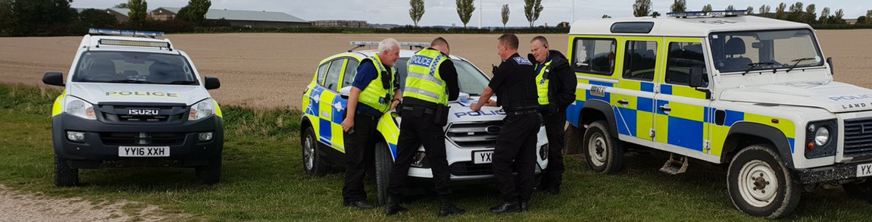
Operation Galileo is the Humberside Police response to tackling and reducing the incidents of hare coursing across the force area. Over the next 6 to 8 months at this time of year there is a seasonal increase in Wildlife Crime, namely illegal Hare Coursing and Poaching.
As part of Operation Galileo dedicated Patrols will aim to prevent and detect this activity with planned days of action. In addition, local patrols will be conducted to deter this type of criminality and will take positive action to anyone caught committing these offences and use the full extent of the law to disrupt this activity as much as possible.
We would like to encourage the local community to report any issues by calling Humberside Police on 101 (non-emergency number) or Crime Stoppers on 0800 555 111.

6. Meet your officers.
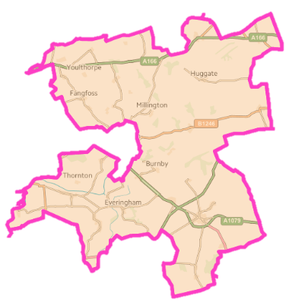

PCSO Nicola Cliffe is one of the PCSOs responsible for policing the Wolds Weighton ward. You can meet Nikki next at:
Market Weighton Town Council, 37 High Street. Market Weighton on:
Friday 27th September - (14:00-15:00 hrs)

You can meet Nikki next at Market Weighton Library on:
Wednesday 16th October - (11am to 12 noon)
Wednesday 27th November – 12 noon to 1pm)

PCSO Laura Hudson is one of the PCSOs responsible for policing the Wolds Weighton ward. You can meet Laura next at:
Wetwang Coffee Morning on the following dates: Tuesday 8th October and 29th October (10:30 -12noon)

- Market Weighton Methodist Church: - Wednesday 2nd October, 6th November and 11th December (11:00 – 12noon)

