**Wolds Weighton Update for July 2019**

**1. Crime and ASB**

TFMV – Theft from motor vehicle

TOMV – Theft of motor vehicle

ASB – Anti-social behaviour

In Market Weighton it is positive to see that all offence categories have seen a reduction in the number of offences in June compared to May. It is also worth noting that although some categories show that there has been a large percentage increase in crime compared to last year, this is primarily due to the number of offences committed last year being so low. For example, Drug Offences increased by 200% compared to the previous 12 months but in reality this was an increase of only 8 offences. Twelve reports of Drug related offences for the entire Wolds Weighton ward in a year is very low in comparison to other areas in the UK. It is also worth noting that although 32 Sexual Offences were reported over the last 12 months, not all of these will include a physical assault and some may be victims reporting historical offences.



Detailed crime and ASB data for your area can be obtained by visiting www.police.uk and following the ‘Find your Neighbourhood’ link. Also details of any particular crimes or series of crimes of note e.g. serious assaults, run of Hanoi burglaries.

**2. Crime issues of particular note**

**The following list shows some of the crimes that have occurred in the previous month in your area.**

* There was an attempted break in of a shed in Sancton and access was also gained into several other outbuildings of a nearby property.
* Entry was gained into an insecure property in Market Weighton, which was then searched and various items including cash stolen.
* Several items including an electric fence energiser were stolen from a farm near Full Sutton.
* Various agricultural weights were stolen from a farm yard near Sancton.

.

**3. Community Priorities**

The Neighbourhood Policing Team meet regularly with partners to ensure we have a multi-agency approach to local issues, individuals and problem solving.  These meetings are regularly attended by partners including Humberside Fire and Rescue Service, Youth and Family Support, Housing Officers, Environmental Health and the East Riding Anti-Social Behaviour Team.  We share information and resources to deal with local neighbourhood issues, in particular, those identified as causing the most harm in the community.

1. **Market Weighton Town Centre area (Evenings):**

We are to continue our high visibility patrols of the Market Weighton Town Centre area to deter potential anti-social behaviour (ASB). These patrols include regular checks on the High Street and peripheral areas of Londesborough Road Car Park, Scotts Croft Memorial Park, the town council building area and the area surrounding the Giant Bradley statue (periodic reports of youths causing annoyance). Criminal offenders will be challenged robustly, arrested or reported for summons. Penalty Notices for Disorder or warning letters may be used in appropriate cases however, those who offend should expect to be arrested and dealt with if their anti-social behaviour amounts to criminal offending.

1. **Youths Causing Annoyance (Evenings):**

Officers will continue patrols in the areas of Aspen Close, the park, the monkey run & football field due to regular reports of low level anti-social behaviour. Anyone caught engaging in such activities will be dealt with jointly with the East Riding of Yorkshire Council.

1. **Vehicle related nuisance**

To reduce anti-social behaviour (ASB) and its impact on the communities within the Wolds Weighton area as well as taking positive action against offenders who cause ASB with their vehicles. Hotspot areas will be checked regularly and any drivers using their cars to cause alarm or distress will be considered for warnings and possible seizure of their vehicles under Section 59 of the Police Reform Act.

**4. Crime Prevention Advice**

# **Distraction Burglars and Rogue Traders**

# **NOT SURE – DON’T OPEN THE DOOR**

A distraction Burglar is someone who gains access to your property by distracting or tricking their way in to steal cash or valuables. This can include claiming to be representing a company or charity to gain entry into homes before stealing items whist the occupants are distracted.

A rogue trader is a cold caller who deliberately overcharges for unsatisfactory goods and /or services. This can include charging for unnecessary work, damaging property deliberately in order to obtain money, leaving work unfinished and intimidating behaviour in order to extort money.

**LOCK, STOP, CHAIN and CHECK**

When someone calls at your door and offers to do repairs to your home, asks for urgent help, or when someone official 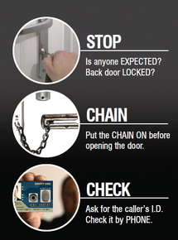knocks on your door, follow these simple steps to help protect yourself and your home from bogus callers.

* **LOCK**: Keep your front and back doors locked at all times, even when at home.
* **STOP**: Before you answer, stop and think if you are expecting anyone. Before you answer the front door, ensure that no rear or side doors and windows have been left insecure. It may be that the caller is trying to distract you while someone else sneaks in.
* **CHAIN**: If you decide to open the door, put the door chain or bar on first. Keep the bar or chain on while you are talking to the person on the doorstep. Some bogus callers call on older and vulnerable people saying they need help urgently. They may ask you to help them outside the house or ask to come in to make a phone call or have a glass of water. Only go to help them if you have someone else with you. Don't worry if you choose not to help it is not rude or unfriendly.
* **CHECK:** If someone who looks official calls at your door, always do the following. Ask for and carefully check their identity card, even if they have a prearranged appointment (all genuine callers will carry one). Do they look like the person on the card? Is the name the same one as that on your letter? Close the door while you do this. If you are not expecting them and they have not shown you an identity card, do not let them in until you have checked and double-checked that the caller is genuine. If you are going to ring the company the caller claims to be from, don’t rely on a number provided by them, you could be ringing an accomplice sat in the van outside.
* If you think the caller is genuine, but you would rather have a friend or relative with you, ask the caller to rearrange to a time when you are not on your own. Don’t agree to any work or sign anything on the spot. Do not be pressured into having any work carried out. Never pay cash up front and never go to the bank or cash point with a trader.

Doorstep crime isn't common, but it can have a long-lasting impact on victims' lives. Remember if you're not sure of a caller, don't open the door

**5. News and appeals**

**Giant Community Day**

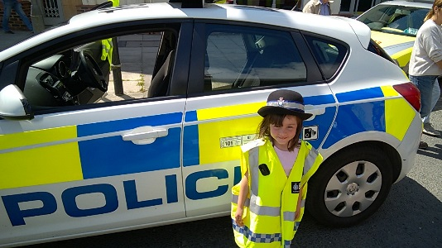Sunday 14th July was the annual Giant Community Day at Market Weighton. The sun was shining and a large number of stall holders, local businesses and volunteers made the day a success for all. Officers attended the show and it was an opportunity for members of the public to come along for a chat about any issues or concerns that they had. Children (and a few adults!) also enjoyed learning about and getting to sit in the Police car.

**School Talks**.

Multi-agency talks have been happening in our local schools: Officers along with the East Riding of Yorkshire Council ASB officer have been into schools to give talks on antisocial behaviour and “No More Knives”. Several schools have also had Fire Assembly talks given by officers and the local Fire Community Safety officer.

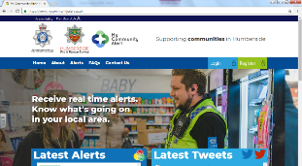

**Stay up to date and follow our new Social Media pages**

Our Response, Investigation and Neighbourhood Policing Teams all use Facebook, Twitter and My Community Alert to share information but we have recently moved on to two new social media accounts. So, if you want to keep up to date with your local policing team please use the website links below:

[](https://twitter.com/hp_goole?lang=en)Follow our Twitter page @Humberbeat_ERYW  
<https://twitter.com/Humberbeat_ERYW>

[Image result for my community alert logo](http://www.mycommunityalert.co.uk/)[](https://en-gb.facebook.com/pages/category/Government-Organization/Goole-Community-Policing-Team-1242414632441324/)Find us on Facebook  
https://m.facebook.com/HumberbeatERYW

Register for My Community Alert  
www.mycommunityalert.co.uk

**6. Meet your officers.**

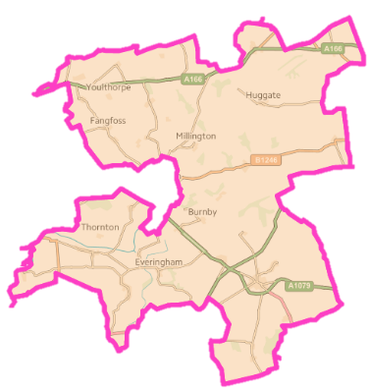

**PCSO Nicola Cliffe** is one of the PCSOs responsible for policing the Wolds Weighton ward. You can meet Nikki next at **Market Weighton Town Council, 37 High Street. Market Weighton on:**

* Friday 19 July, 10:30am – 11:30am

**PCSO Laura Hudson** is one of the PCSOs responsible for policing the Wolds Weighton ward. You can meet Laura next at:

* **Wetwang Coffee Morning** on Tuesday 23rd July (10:30 -12noon)
* **Market Weighton Methodist Church** onWednesday 24th July (11:00 – 12:00)