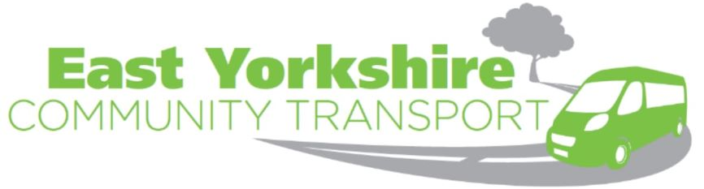

Volunteer Opportunity
East Yorkshire Community Transport Limited provide a 5 day a week hospital transport service to major acute units in Hull and Scarborough for residents based in the Bridlington, Goole, Howdenshire and surrounding areas. This project is divided into two individual services. Goole GoFar will provide community transport operations in the Goole, Howdenshire and surrounding areas, whereas HART provide operational services in Bridlington and its surrounding areas. The project is called the Home 2 Hospital (H2H) Transport service.
The H2H Transport Project provides affordable transport for residents that are generally elderly, vulnerable and isolated, however, the transport will be targeted at those people who have transport as a barrier to appointments and medical care at major acute units in Hull and Scarborough.
This is an EYCT project but is facilitated by both The Goole and District Community Transport Group (Goole GoFar) and The North Holderness Community Transport Ltd (HART). We are, therefore, looking to recruit volunteers to aid the new Home 2 Hospital service to work in the Goole and surrounding area as well as the Holderness and Bridlington area.
We feel there is no such thing as the “ideal” volunteer. Everyone brings their own motivation, skills, experience, and personality into their voluntary work. However, there are some qualities which we feel volunteers need to have. These include being:
  - Patient and sensitive to the needs of others.
  - Honest and trustworthy
  - Reliable and punctual.
  - Tolerant, non - judgmental and able to keep confidentiality.
  - Able to work on their own initiative or as part of a team.
New volunteers will need to fill in a driver details form which asks for your license details and driving history. To be eligible to drive our minibuses volunteers must:
- Be aged over 25 (for insurance purposes).
- Have a full driving license with D1 entitlement.
- The following endorsements are allowed: SP 10, 20, 30, 40, 50 and 60/ TS 10, 30 and 50 (we will only consider a volunteer with a maximum of 3 penalty points on their license).
- In good health – if taking medication, we may ask you to complete additional forms.
- Be able to provide 2 references. Referees must be over 21; have known you at least two years and should not be a relative. We also ask for a declaration of previous convictions (as the Rehabilitation of Offenders Act 1974, Exemption Order 1975 does not apply). This would not necessarily exclude the volunteer from working with us, but we would need to seek additional professional advice and references.
- Complete an initial driving assessment where volunteers will go out with a trained member of staff.
- Successfully complete MiDAS training (1 day in house course) and successfully complete a Disclosure and Barring Service check which we will complete with the volunteer.
If you feel this is something of interest to you or a member within your community then please call East Yorkshire Community Transport Limited on 01405 780344
Kind Regards
Andy Jackson
EYCT’s Development Coordinator

