North Dalton Village News

November/December 2021
Autumn comes round again and as the trees change colour and the conkers fall our thoughts turn to colder days ahead and, dare I say it, Christmas on the near horizon. But never fear, here in North Dalton there are plenty of things to warm your cockles! We’ve got some great Christmas activities planned in the village (provided we don’t get scuppered by Covid again) and our village pub should be re-opening in Spring 2022– and the news doesn’t get much better than that!

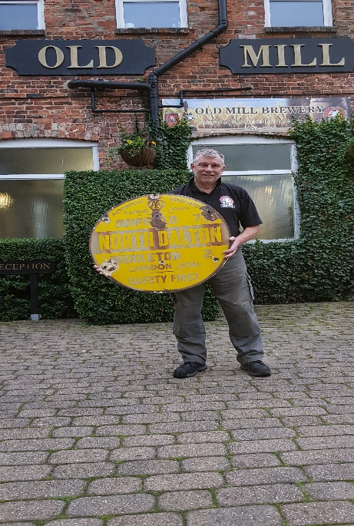
A Star Re-born
The Star Inn has been purchased by the Old Mill Brewery, a family business based in Snaith, East Yorkshire. Old Mill own another 16 pubs across Yorkshire and Derbyshire as well as producing their own cask ales. Contacted by the village newsletter, Mark Wetherill from the brewery quickly responded and told us: ‘We have lots of exciting ideas and plans for the future of The Star Inn, returning it to a warm and welcoming local village inn, serving high quality home cooked English fayre and great Old Mill award-winning ales. We cannot wait to get it back open and to get involved in the village’. Real ale buffs will be pleased that they hope to serve 2 permanent cask ales and, a monthly seasonal ale, if throughput is sufficient. However, as Mark points out there is some major work needed, and the brewery hopes to install a commercial kitchen as well as create an outdoor seating area. There is also good news about the iconic AA road sign which had gone missing from the pub wall. Mark told us that with the help of the Star’s previous owners, the sign is now back in the hands of the Brewery, and it will be refixed as part of the pub’s refurbishment. All being well, the Star should re-open its doors in March 2022. Cheers to that!

News from the village hall: The hall has gradually re-opened during 2021, and we’re pleased that some of the hall’s regular activities such as Jo’s yoga socials, Vista Arts workshops and, of course, the monthly coffee mornings have resumed and are as enjoyable as ever. In September, North Dalton played host to the High Wolds Poetry Festival, now established in the annual calendar, organised by village resident Julian Woodford. Recently, a delighted audience enjoyed an evening of Indian dance and music by the Balbir Singh Dance Company. This was supported by Artery (Art in the East Riding) which helps to bring performances to village halls. We have another Artery evening on November 12th with the funny and talented duo Simon Mayor and Hilary James. We are planning a Christmas party on Saturday 11th December with a Children’s Party the same afternoon.

Parish Council news A sub-committee of the PC has continued to investigate the condition of the pond, including consulting an expert hydrologist and a biologist who have recommended aquatic plants to improve the water condition. The pond is not very deep with a thick layer of silt, samples of which are being analysed. There are plans to reduce the duck population by re-homing some to a private lake several miles away. Community Speed Watch volunteers are continuing to do regular traffic checks on Main Street. Results are sent to the Police who notify anyone found to be breaking the speed limit with action taken if this is repeated several times. The PC is also setting up a meeting with other Parish Councils and officers from ERYC (Highways and Planning) to discuss the traffic situation in the local area and arranging for an Officer from the Highways Department to visit the village to look at our particular problems. Finally, thanks to a generous donation from a local resident, a new litter bin has been installed on Main St, near to Hudson’s Lane. More information about the PC is available at http://northdaltonparishcouncil.org.uk
North Dalton History Weekend The Village Hall has had a small grant from The National Lottery’s Local Connections Fund for a 'sharing memories' event. We know that many of our older residents have a wealth of stories about local life which would be lovely to share with each other and with younger and more recent residents. We would also like to borrow and scan photos for a local history exhibition and maybe invite some outside speakers and other exhibits/films for a local history weekend on 22nd/23rd January. We are seeking volunteers to help plan this weekend and really want your ideas, so please contact Sara 217216; 07730 885400 or Sara@dmss.co.uk
Church news the Church’s Harvest Auction was back at the village hall this October, raising a splendid £850 to maintain our beautiful church. Some repairs to the East Gable end will be starting soon.
Services Sat 6th November: Holy communion at 6pm with Rev Jane Anderson
Sun 14th November: Remembrance Service at 9.30am to include wreath laying at war memorial;
Sat 4th December: Holy Communion at 6pm
Sat 18th December: Carols by Candlelight at 6pm and Fri 24th December: Christingle Service at 6pm.
The church will be decorated for Christmas on Friday 17th December – volunteers welcome.

The Parochial Church Council also plans to host its traditional Senior Citizens’ Christmas Lunch again this year, hosted at the village hall on Tuesday 14th December with the option of meal deliveries to those unable to get to the hall. The PCC is seeking both volunteers and donations to help with this. For more details, please contact Nick (07801798994, 01377 219428 or nickbarkerwyatt@gmail.com)

Events at a glance
- Every Friday 10-11.30 or 2-3.30: Jo’s Yoga Social: Accessible chair yoga. A gentle way to better health, strength, flexibility, balance and reduced stress. £5 including homemade cake. Contact Jo 07710 244026
- Thursday 11th Nov 9.30 to 12 noon: Coffee & Chat: Meet friends & neighbours & enjoy delicious teacakes and homemade goodies. Just turn up. Everyone welcome, including volunteer helpers - contact Trish 217967
- Friday 12th Nov 7.30pm: Simon Mayor & Hilary James 'Virtuoso mandolin, elegant vocals, guitar and fiddle wizardry, and a stage show that ranges from witty to hilarious. Tickets £7.50. Contact Rose 217625
- Thursday 9th Dec 9.30 to 12 noon: Coffee & Chat: Meet friends & neighbours & enjoy delicious teacakes and homemade goodies. Mince pies very likely!
- Sunday 14th November 9.30am: Remembrance service & wreath-laying at the War Memorial
- Saturday 11th Dec 4 til 5.30: Children’s Christmas Party. Games, food and party bags! Free to all local children but we need to know numbers so to book places contact Sara 217216 or text 07730 885400
- Saturday 11th Dec 7-30 til 11pm: Village Christmas Party. Music, bar and fun! Free entry – just buy your drinks from the bar.
- Tuesday 14th Dec 12 for 12-30: Senior Citizens’ Christmas lunch. To book your place or to volunteer or donate contact Nick 219428 or 07801798994
- Sat 18th Dec 6pm: Carols by Candlelight, All Saints Church, North Dalton
- Tues 21st Dec from 7pm: Community Carol Sing by the War Memorial/Christmas tree– sing your favourites then head to the village hall for a warming tea/coffee. Collection for charity. If you can’t get out but would like some Carols at your door, we will arrange it! contact Ray 217356
- Fri 24th December: Christingle Service at 6pm, All Saints Church, North Dalton

