Devolution Summary

Back Ground
- Devolution in England has been a topic of the political scene since the early 2000s.
- In the last ten years it has accelerated to become a main priority for Government. This now takes the form of the Government’s Levelling Up white paper (a 2019 Conservative manifesto promise). The Paper pledges to devolve all of England by 2030. The details of the paper will be discussed later.
- In terms of our area, East Yorkshire, four geographies for devolution have been explored:
- Firstly, there was the idea of One Yorkshire, a Yorkshire Wide devolution deal.
- Initially, there was a proposal for a Yorkshire Parliament/Assembly type system. This was rejected by the previous Labour Government as they felt it was not supported by the population.
- Secondly, there was a proposal for a Yorkshire-wide Mayoral Authority. This was rejected by the Conservative Government because it was deemed to be too large an area to devolve powers to; and West and South Yorkshire already had devolution deals by this point.
- Negotiations then started to look at a potential Humber-wide devolution deal involving, The East Riding, Hull, North Lincolnshire and North East Lincolnshire. This was a geography which seemed to be favoured by the Government because of the economic area around the Humber estuary. However, negotiations ended on this when the south bank Lincolnshire authorities withdrew as they wished to form a Greater Lincolnshire devolution deal instead, meaning a Humber-wide deal is no longer possible.
- Forming a devolution deal with North Yorkshire was then explored, forming a North and East Yorkshire Devolution deal. However, negotiations on this ceased when North Yorkshire pulled out and decided to form their own devolution deal. Meaning a North and East Yorkshire Devolution deal is also no longer possible either.
- With our remaining neighbour, South Yorkshire, already having its own devolution deal, this left us on our own. The Government therefore, made us a special case, and allowed us to form our own East Yorkshire (East Riding and Hull City) Devolution Deal. This would be far smaller than the 1 million population threshold for a devolution deal the Government had been pushing. Work has been ongoing since 2019 to explore what type of devolution deal East Yorkshire Could have. There are two deals on offer, which are explained in the Levelling Up white paper. This will be explained shortly.
- Just before you we do that, let’s get an understanding of the aims of Levelling up and therefore, devolution.

Levelling Up - what is it’s aims for England?

- To make a decision on devolution, we need to understand what the Government is trying to achieve as part of their Levelling up agenda.
- The First aim of levelling up is to bring the economies of the North, Midlands, and South West up to the same level or beyond that of London and the South East. And therefore, bring the economic opportunities of the people of the North, Midlands, and South West in line with those of the people of London and the South East. This is to be done by improving things, such as infrastructure and transport, education and skills, public health, and housing in these areas (using devolved funding), to attract business and investment into these areas, improving and broadening the opportunities available to the populations of these areas and therefore, hopefully, improving the lives of the people of these areas.
- The Second aim is to empower communities which for so long feel that they have been left behind. To give people a say over the direction of their local area, and make them proud of their area. This is to be done by taking powers and funding from Westminster and putting them into the hands of local people. The aim is also to make the people making the decisions more accountable.
- The main tool the Government wants to use to deliver these aims is devolution.

Devolution Deals:

- In the Levelling Up White Paper the Government outlines three ‘levels’ of devolution. Three different types of devolution deal, which are ranked from Level 1 being the least beneficial type of devolution up to Level Three which the Government sees as the most beneficial devolution deal. It also makes it clear, that it wants devolution to be a community led project, in that it wishes local areas to tell the Government which type of devolution deal they want through their local authorities.
- Level 1: This deal is designed for County Council areas who do not wish to become a unitary authority area. East Riding and Hull are already unitary authorities, and therefore, this deal is not available to us. It is also the deal with the least powers and funding from Government.
- Level 2: This is the County Deal. This deal is currently favoured by the Labour Leader of Hull City Council, and the Conservative Leader of East Riding Council. They are currently in negotiations with Government about this deal. At this time there are no examples of County Deals. A County Deal gets you more funding and powers than a Level 1 deal, but less than a Level 3 deal. We will go through the details of this shortly.
- Level 3: This is the Mayoral Combined Authority Deal (MCA). In the Government’s eyes this is the most beneficial deal for areas, as it comes with the most funding and the most powers. It is also the deal which by far most delivers on that second aim of levelling up, empowering the people and holding decisions makers to account because it gives people the direct control (through election) of who is leading the region and our futures; a directly elected mayor who is elected by the people for the people and mandated by the people. Back in 2020, the then Conservative Leader of East Riding Council, and then Labour Leader of Hull City Council submitted an expression of interest to Government to look at the possibility of a Mayoral Combined Authority. Negotiations on this ceased when the current leaders submitted their expression of interest for a Level 2/County Deal in 2021. There are now multiple MCA’s across England, with the most well-known examples being Greater Manchester, under Labour Mayor Andy Burnham and Tees Valley, Under Conservative Mayor, Ben Houchen. There are also examples closer to home; West and South Yorkshire both already have MCAs and North Yorkshire is currently working towards one. The MCA gives areas the most powers and funding from Government. We will look more at the details of the MCA shortly.

Structure of a Level 2/County Deal:

- County Board:
- The head and leading organisation of this deal.
- The Board will control the powers and funding devolved from Government (A table will show these exact powers later).
- Who will sit on the board? The makeup of the Board would be confirmed as part of negotiations. However, for definite, the Leader of East Riding Council, and the Leader of Hull City Council would sit on the Board. Other potential members could be people like, the Chief Executive Officers of each council, the Chief Executive Officer of the County Board, the Police and Crime Commissioner, The Chairman of the Local Enterprise Partnership. It is important to note that no members of the Board are directly elected or mandated to their role by the people.
- The head of the County Board alternates every six months between the leaders of the two authorities.
- Local Authorities:
- Underneath the County Board initially would remain the two Local Authorities.
- Both would still have their own elected members and generally their own autonomy as they do now.
- However, under a County Deal the Government wants to see the local authorities merge service delivery where possible in the aim of efficiency. Therefore, under a County Deal Hull and East Riding Councils would have to merge certain services.
- Parish and Town Councils:
- Will remain as they are now.

Elected
Appointed

Structure of a Level 3/Mayoral Combined Authority Deal:

- The Mayor:
- The Mayor is the head and leading figure of this deal. Elected and mandated directly by the people; they will set the direction of how the additional powers and funding from Government are used.
- Completely separate to the Local Authorities.
- The Mayoral Cabinet:
- The Mayoral Cabinet will serve as an assisting body to the Mayor, advising The Mayor on decisions of where and how to spend the additional money from Government. They hold the Mayor to account, assist them in their duties to the public and ensure not all power lies solely in the hands of one person.
- The makeup of the Cabinet would be decided and confirmed as part of negotiations. However, it seems that the leaders of each council and the PCC would definitely have seats.
- Completely Separate to The Local Authorities.
- Local Authorities:
- Will remain exactly as they are now, fully autonomous and separate to the Mayoral Authority and each other.
- Parish and Town Councils:
- Will remain as they are now.

- Local Authorities and the Mayoral Authority, contrary to what the title of this deal suggests, will not be combined, and all three organisations will be/remain autonomous, but work side by said for the good of the area.

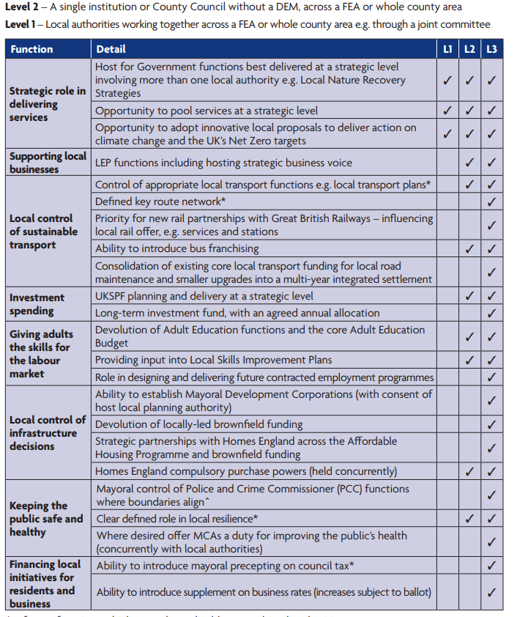
The Powers and Funding:
- Table from the Levelling Up White Paper showing the different powers on offer to the three different levels of devolution.
Powers/funding important for the East Riding which can only be secured with a Level 3 deal:

Powers most relevant to East Riding.

