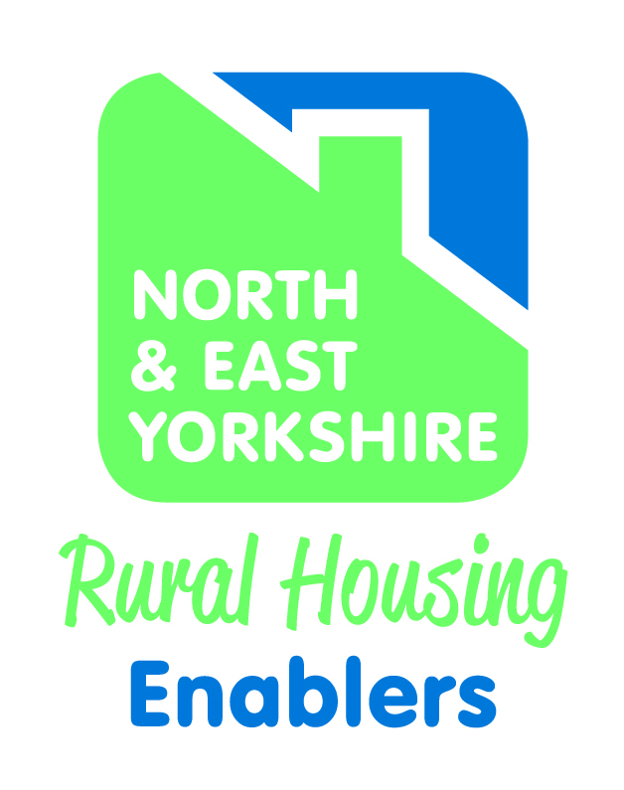

NORTH DALTON HOUSING NEEDS FOLLOW UP SURVEY
August 2019

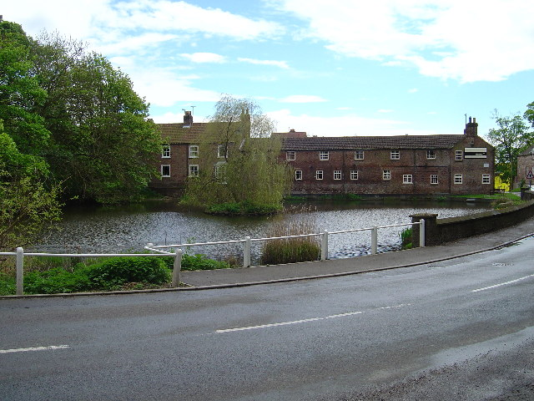
David Siddle
Rural Housing Enabler
East Riding of Yorkshire Council

CONTENTS | PAGE
- Background | 3
- Follow Up Survey Findings | 4
- Analysis of Comments | 9
- Summary and Recommendations | 9
Appendix 1 Survey Form | 10

- BACKGROUND

  - The Village

North Dalton is a village of around 300 people (132 households) about 10 miles north west of the large market town of Beverley and 8 miles south west of the smaller town of Driffield. It lies on the B1246 – an important route linking the Wolds and Vale of York with the coast and the surrounding area. It lies in the heart of the Wolds in an area dedicated to arable farming and ancillary businesses. The nearest main rail stations are at Beverley and Driffield and it has a limited bus service running between Driffield and Pocklington.
Out of its population of 302, people of working age (ages 16-64) account for 58% of the total population (or 176 people).
North Dalton has a village hall and a public house but no other commercial or community facilities. It also has some sports facilities including a cricket pitch and assorted playing fields. The village also boasts a duck pond.
.
A map of the parish and its boundaries is set out below:

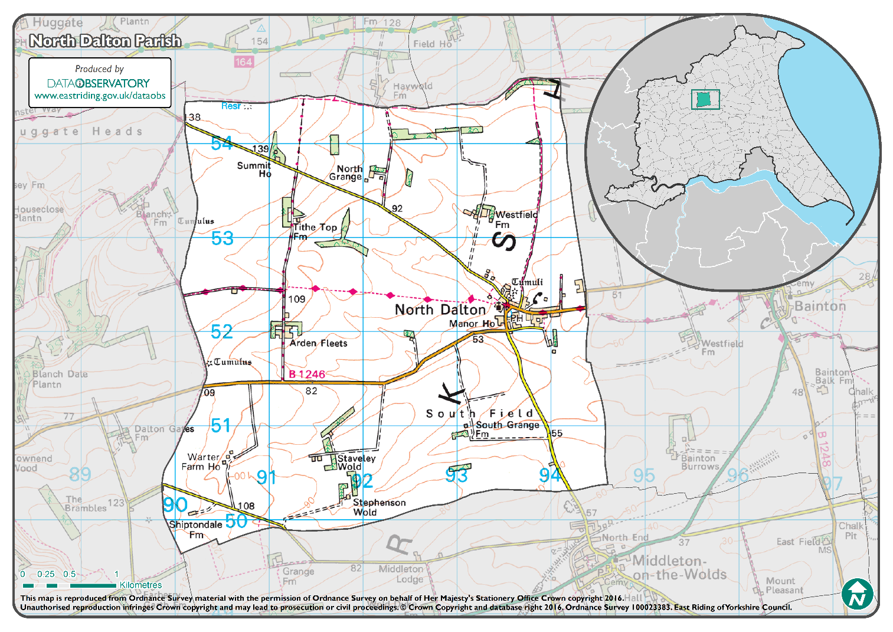

  - Housing Needs Survey

During July/August 2018 a survey form was made available to residents (either a paper copy or online) for anyone who felt they might be in need of rehousing either now or within the next three years and who had a local connection with North Dalton or its surrounding parishes.
A relatively small number of forms were returned (16), but the report concluded that this was sufficient to demonstrate that there is a degree of need in the area for some affordable housing either for rent or sale.
The respondents came from all tenures and had a wide range of needs. In the main, they were looking for smaller accommodation – either 2 bed housing or 2 bed bungalows. Nearly half the respondents came from North Dalton with smaller numbers from Huggate, Bainton, Middleton on the Wolds and Tibthorpe.
The report subsequently recommended that a small infill scheme of between 4 and 6 homes for rent (a mix of houses and bungalows ideally) could be developed should a suitable site be identified. A further phase of starter homes for home ownership could be considered if demand was proven. The first choice location for such a scheme is North Dalton.
Following meetings with the Parish Council in January, February and May 2019, it was agreed that a further survey should be carried out with the wider community of North Dalton to gauge attitudes to new housing and in particular to the provision of affordable housing.
A survey form was distributed to all households in the village on 19th June with a closing date of 8th July (see Appendix 1). This report sets out the survey’s findings.

- FOLLOW UP SURVEY FINDINGS

Q1. Who responded?
Seventy two completed forms were returned over a three week period. This is a good turnout (well over 50% of all households in the village).
All 72 respondents had a connection with the village. There were 69 who stated that they lived in the village with 14 of these also stating that they also worked there. Nine respondents had close family connections within the village. Three households were from outside the village but worked in the village.

Q2. Do you think there is a need for new housing in the village? If ‘Yes’ what type of homes do you think are needed?

This question prompted answers from 72 households. Numbers were roughly even with a small majority rejecting the proposition that there is a need for new housing in the village. 35 said there is a need with 37 saying ‘no’.

For those who answered ‘yes’, most considered smaller house types were needed. Semi-detached, terraced and bungalows were the preferred house types and there were more votes for 2 bed housing than any other.

Only a small number of responses were recorded in favour of 4 bed housing.

There was some limited interest in live:work units and eco homes.

Q3. Do you feel that the right type of housing is getting built in North Dalton?

This question reveals that a small majority consider that the right type of housing is getting built in the village. From those who answered the question, there were 35 respondents who supported the proposition against 25 who were not.

This probably echoes the answers in Question 2 where 37 households felt there is no need for new housing. It implies that larger ‘executive style’ houses (the type that has been built in the last 10 years) does have some support although others commented that this type of home would only attract households with high levels of income.

Q4. Do you feel there is a need for affordable housing in the local community for those who cannot afford to buy outright or rent privately? If so, please tell us what type of housing should be developed.

This question also elicited a very close response. Whilst 35 felt there is no need for more affordable housing there were 36 respondents who felt that there is a need.

Of the types of affordable housing, a mixed picture emerges with no one type of housing being the clear favourite (although housing for rent does get support from 43% of the preferences expressed)

(Note – respondents had the choice of ticking more than one box; and many did)

Q5. Which site would you prefer to development take place (Well Garth or Back Lane).

Two sites have been provisionally identified for affordable housing – one at either end of the village.

Well Garth is at the end of a cul-de-sac of council houses and former council houses and would be taken from grazing land.

Back Lane is on a small lane leading from the south eastern entrance to the village. It is currently used as a paddock.

Both sites are outside the development boundary of the village and would be treated as rural exception sites should either be submitted for planning approval.

From the survey, it can be seen that there is a preference for affordable housing to be located in Well Garth rather than Back Lane (24 votes as against 12 votes). Eleven votes did not express a preference.

Added to this there were 24 who stated that neither site was a preferred option. However, 21 of these responses came from people who did not consider there was any need for affordable housing and so were likely to be very ambivalent to any site being suggested for new housing.

Q6. Are there any other sites?
One alternative site was suggested by 6 respondents and this is on the corner of Mill Lane and Main Street. This too is outside the development boundaries of the village and would be treated as a rural exception site. It does not appear to have any impediments to development and should be considered alongside the other two.

Q7. What age group are you?
The vast majority (36) are in the 50-69 age category with just 17 being older and 18 being aged between 26 and 49 years old. Only 1 person was aged under 25.

Q8. What type of house do you live in?
Twenty six households live in either detached or semi-detached homes. Smaller numbers are in bungalows or terraced houses.

3. ANALYSIS OF COMMENTS
The form offered several opportunities to make comments on the need for new housing in the village. Rather than restate each comment in turn (a task that would be rather unwieldy), this report seeks to set out the main areas of concern.
Overall there is some concern that the village has no facilities (including the poor bus service) with over 10 respondents having listed both as issues. Smaller numbers made general observations about development not being needed and other villages being better suited. Conservation and environmental issues also need to be taken into consideration in addition to other safety and traffic management issues.
In support of the general concept are those who state that affordable housing will meet local housing needs (11 respondents) and it can help to keep people in the local community (3 respondents).
In terms of the specific sites, there were concerns voiced on both of the sites. Back Lane opponents concentrated on access difficulties, safety and traffic issues and general environmental/conservation issues.
Well Garth opponents had similar concerns but their numbers were fewer.

- SUMMARY AND RECOMMENDATIONS
  - Mixed response – no clear majority for a specific course of action but a substantial number support the principle of affordable housing subject to identifying the right site.

  - No clear mandate for any particular site. Is there a need to look more closely at the 3rd site (Mill Lane)? A plan of a course of action is required to identify a preferred site.

  - If it is accepted that there is sufficient support within the village to progress a small scheme a little bit further, then the following action is proposed:

    - Identify a preferred development site in consultation with the parish council and the partner housing association

    - Commission the housing association to prepare a feasibility study (on the preferred site)

    - Undertake a further consultation exercise for any scheme prior to engaging in the formal planning process

    - At the same time assess the housing needs and demand in the village (and surrounding parishes) through this informal consultation process
NORTH DALTON HOUSING NEEDS SURVEY
FURTHER CONSULTATION
June 2019
The housing needs survey conducted last year concluded that there is a limited need for new affordable housing for rent in the village. The Parish Council is wanting to seek your opinion on whether to meet these needs within the parish.
This survey is also designed to seek your views on what sort of affordable housing would be best for the village and whether you have any views on possible sites that could be pursued.
- What is your connection to the village? (Tick all that apply)
Live in the village
Work in the village
Have close family in the village
Used to live in the village and have strong connections

- Do you think there is a need for new housing in the village? (Please circle your choice)

YES / NO

2a. If YES, what type and sizes of new homes do you think are needed in our village?

House Type | 2 bed | 3 bed | 4bed
Detached Houses
Semi-detached/terraced houses
Bungalows
Houses with workshops for cottage industries

Eco-Homes
Other (Please specify

- Do you feel that the right type and amounts of housing are getting built in North Dalton?
YES / NO

3a. Please provide any further comments you may have on this:

- Do you feel that there is a need for affordable housing to meet the needs of those households in the local community who cannot afford to buy outright or rent privately? (Please circle your choice)
YES / NO

4b. If you answered ‘Yes’ to Question 4, please tell us what type of affordable housing you think should be developed?

Tenure type | Please tick
Affordable housing for rent (based on a local lettings policy)

Shared Ownership - (Part own/ part rent) (based on a local sales policy)

Discounted Sale – (purchasing a home at a discounted price where a local connection is required)

4c. Please provide any further comments you may have on this:

Two sites have been identified for a small scheme of affordable housing of around 4 to 6 units. One is located at the end of Well Garth and one on Back Lane (see map)

5a. On which site would you prefer to see development take place?

Well Garth Back Lane

No preference Neither

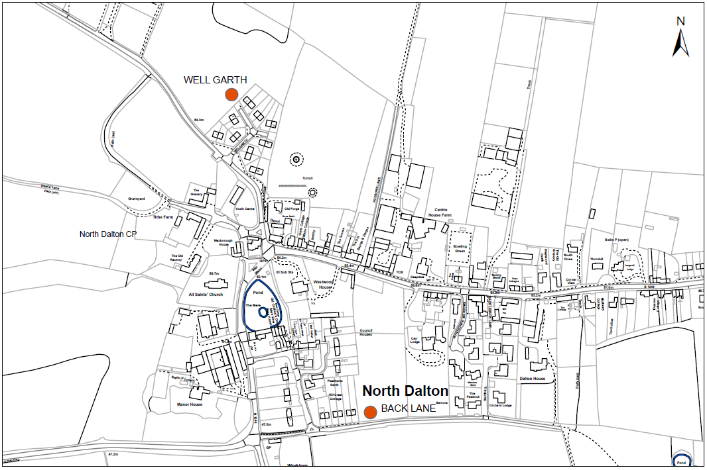

5b. Please provide any further comments supporting your choice:

- Are there any other sites you would wish to draw to our attention?

- To which age group do you belong? (Please put a x in one of the following)
Age range | Please select
0 - 18
19 - 25
26 - 49
50 - 69
70 +

- What type of house do you live in?
Please select
Detached House
Semi-detached house
Terraced house
Bungalow
Flat

Please return the form in the prepaid envelope provided by 8th July

